**Scenario -1 (Volumes)**  
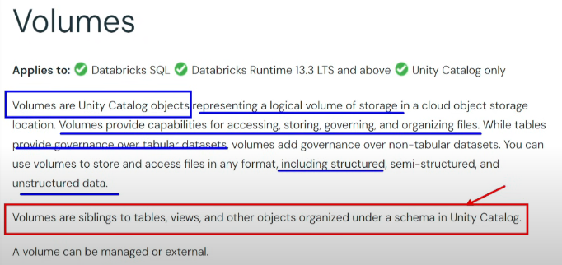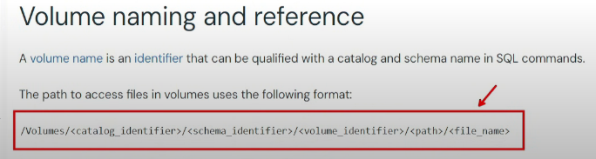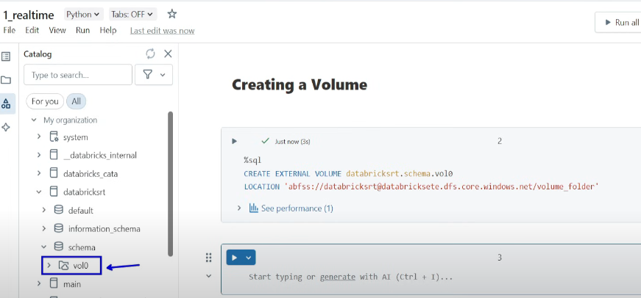Upload the file in ADLS Gen2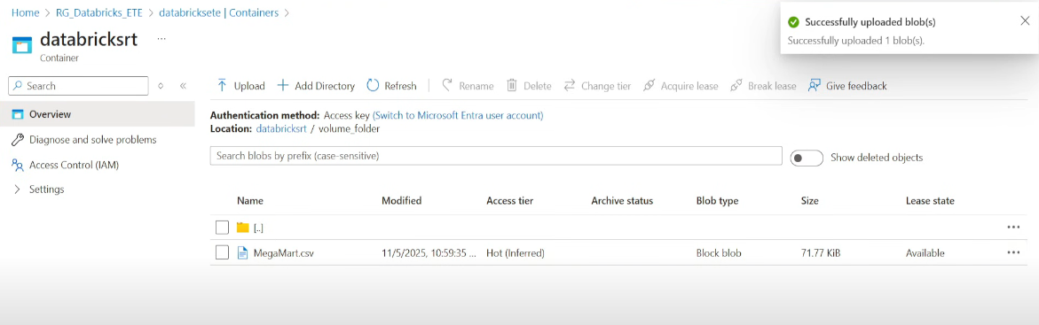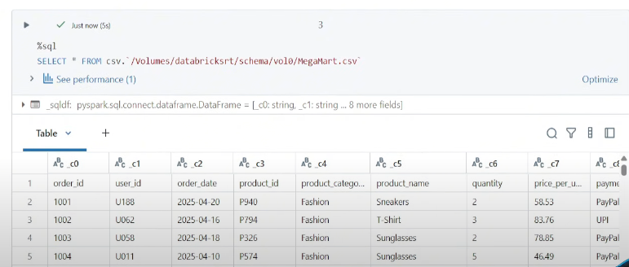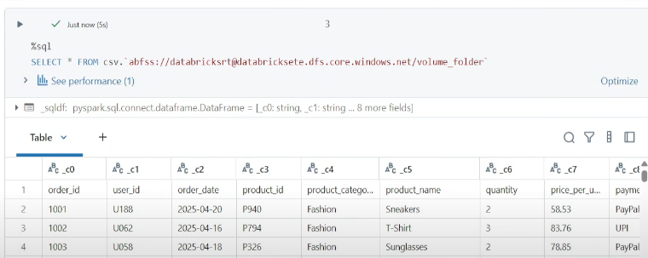  
Both are same, but why do we need Volume 🡪 Volumes are governed, can be tracked using UC

**Scenario-2**   
Looping through files in folder   
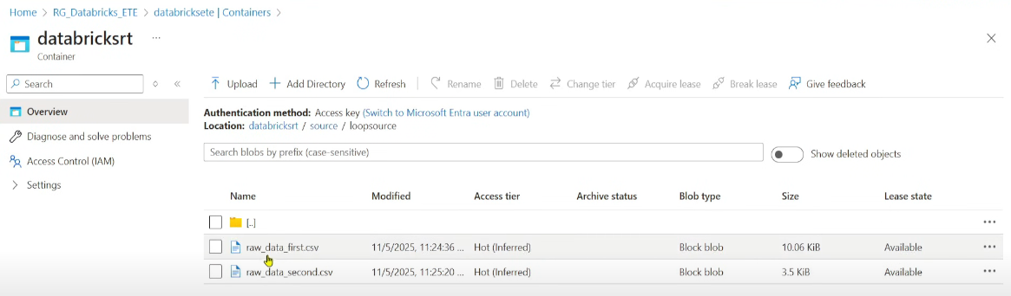

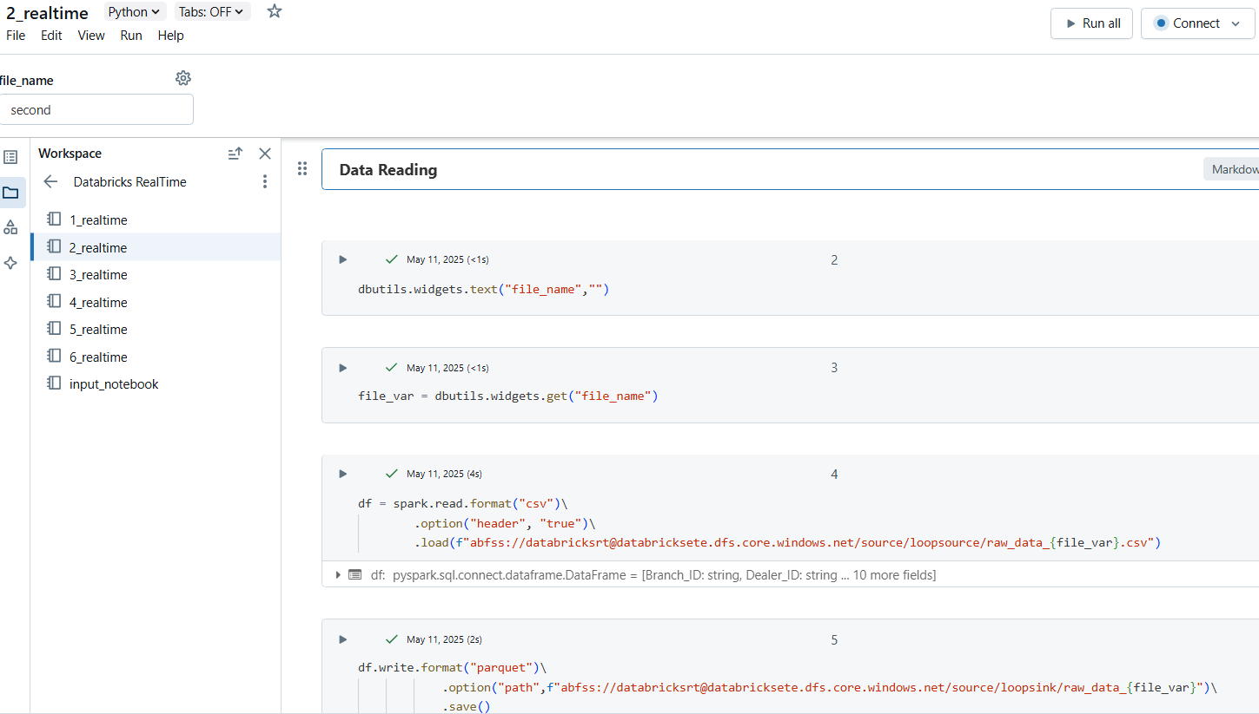 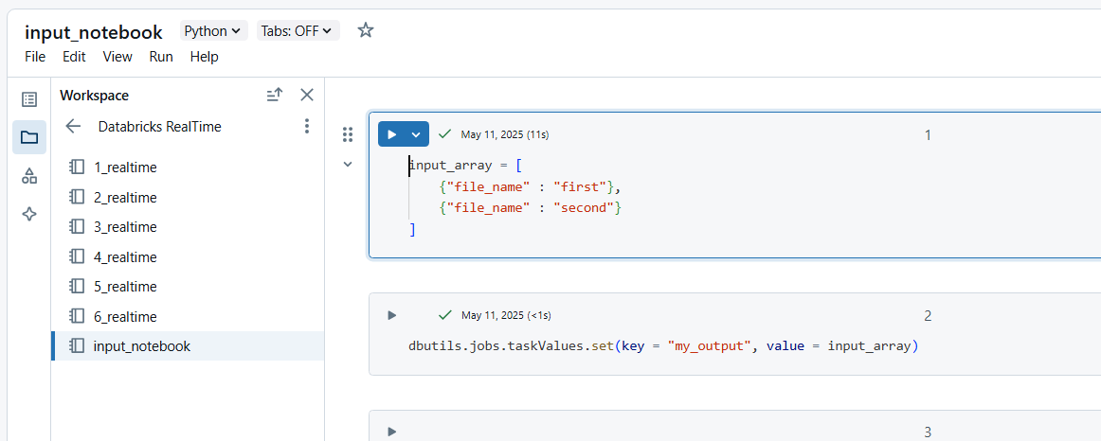  
Create a job in Workflows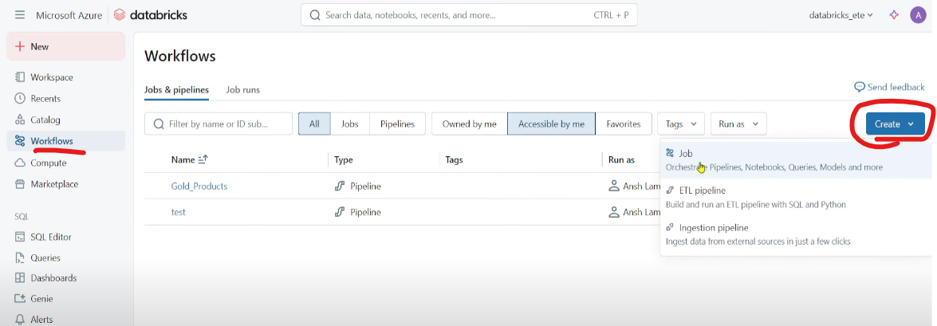  
Job : Normal Workflows  
ETL pipeline : DLT  
Ingestion pipeline : No code ingestion pipeline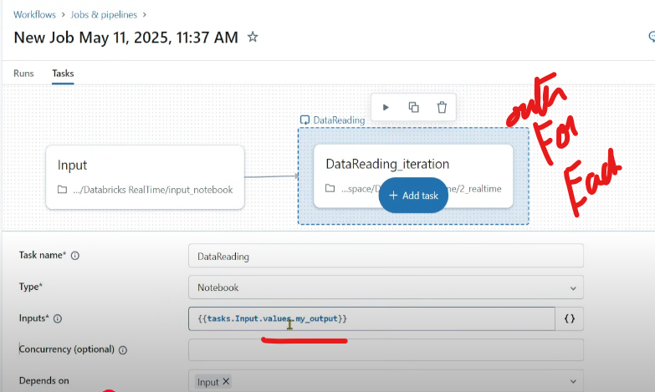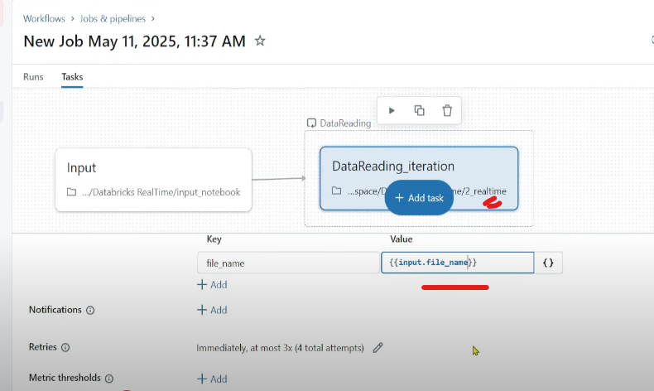

**Scenario – 3**  
Bring on prem data to our organisation without moving the data, query data sitting outside of Databricks/managed layer/cloud without moving the data  
Concept called Lakehouse Federation  
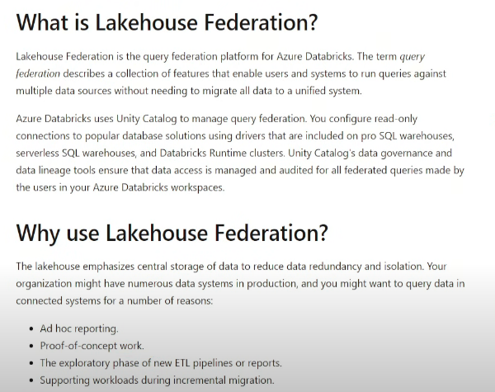  
Catalog 🡪 External Data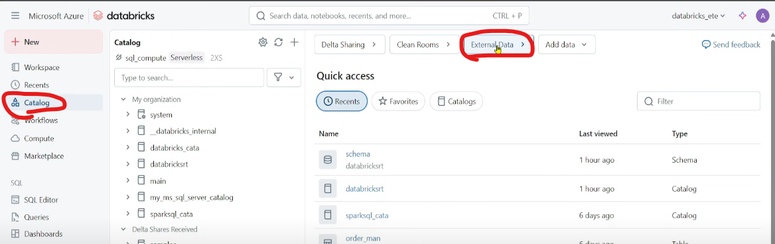  
Connections 🡪 Create Connection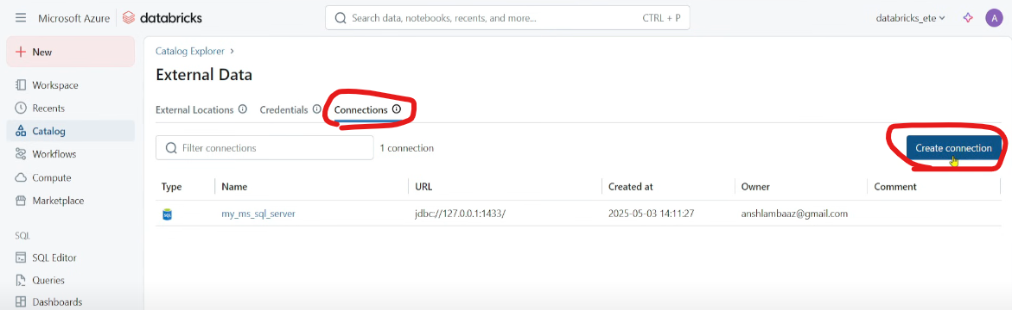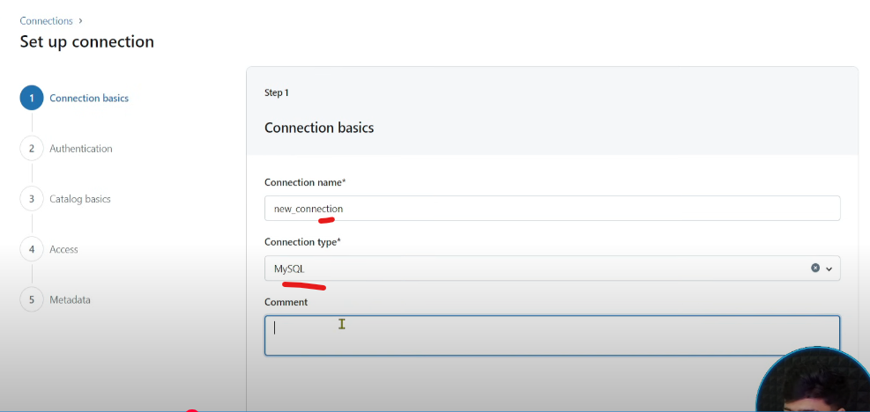  
There are crazy amount of sources in Connection Type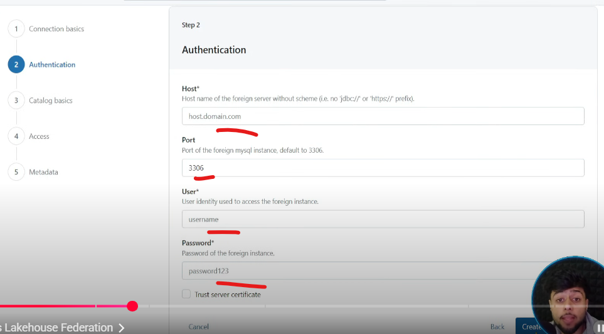  
Provide all these details 🡪 Create a new catalog🡪 access 🡪 metadata  
Post that you can query the data sitting in onprem from DB workspace

**Scenario – 4 (AutoLoader)** 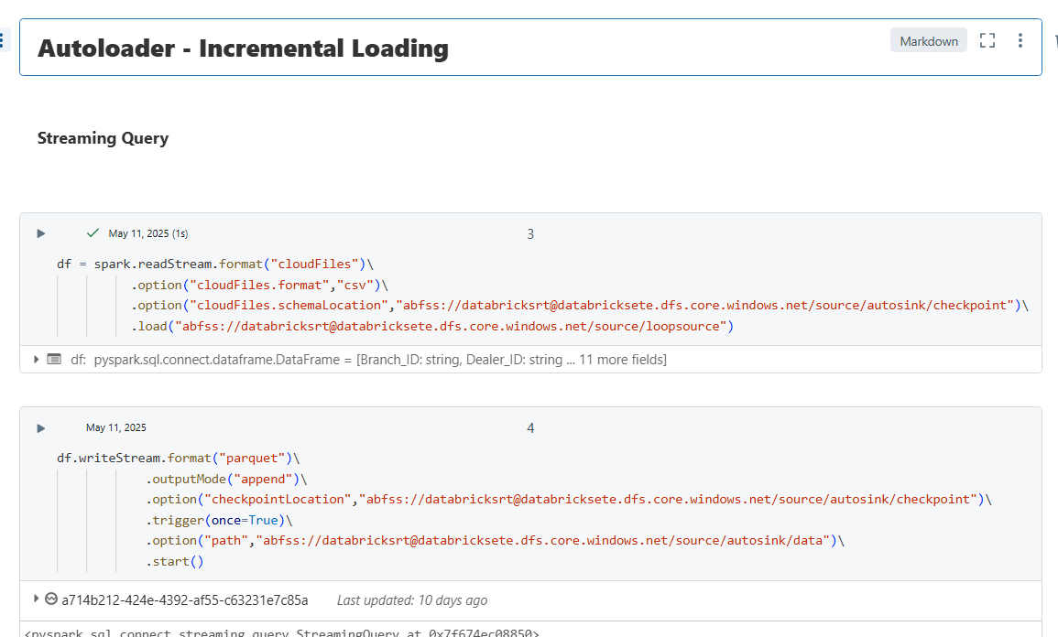

**Scenario – 5 (UC access control)**  
Granting access to new user  
Step1 : Add user in the Entra ID (Go to Entra ID🡪 Manage 🡪 Users )  
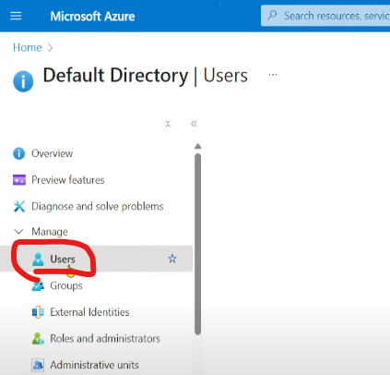 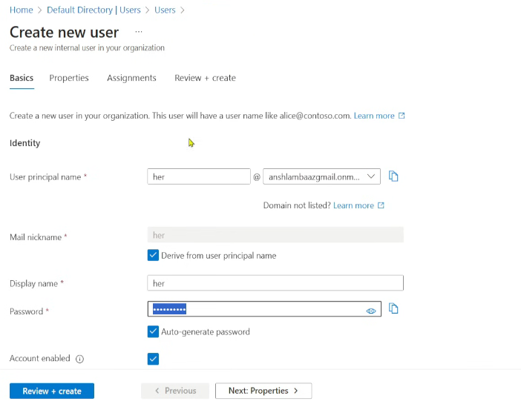 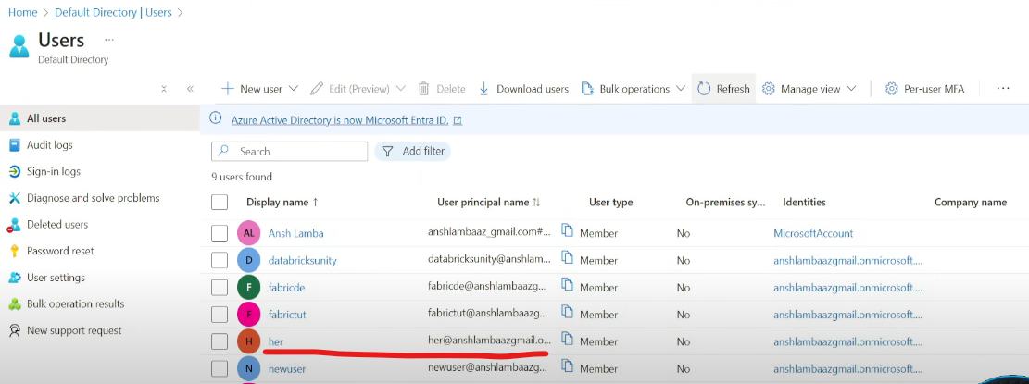  
Step2: Add user in Databricks workspace 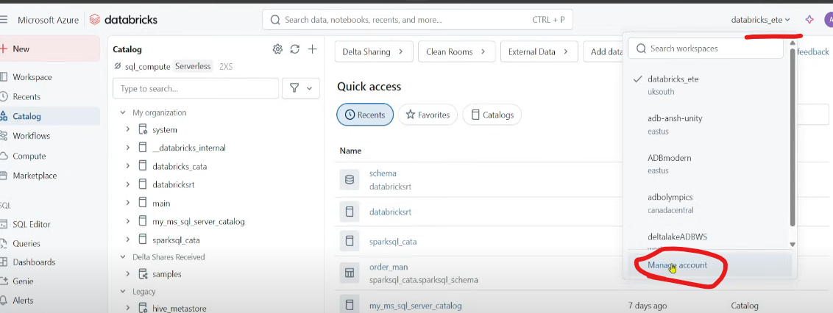 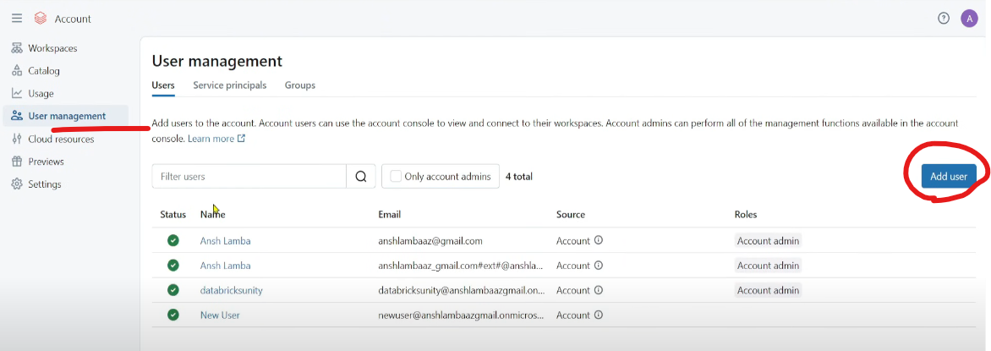 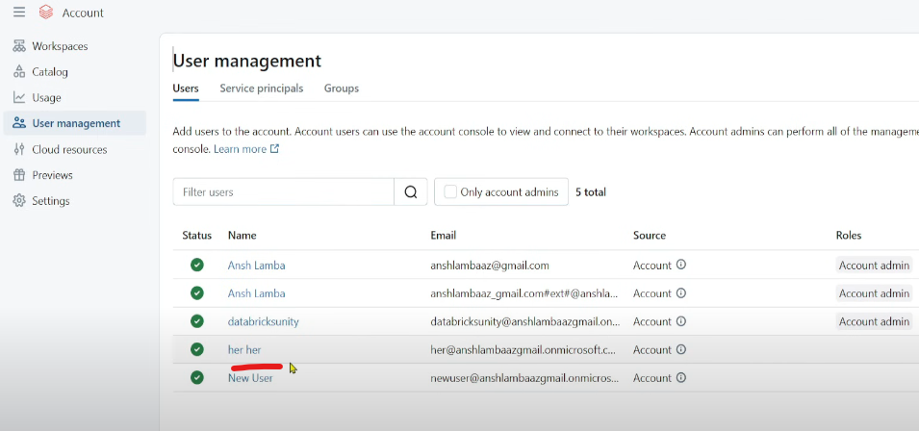  
  
Now login through her id 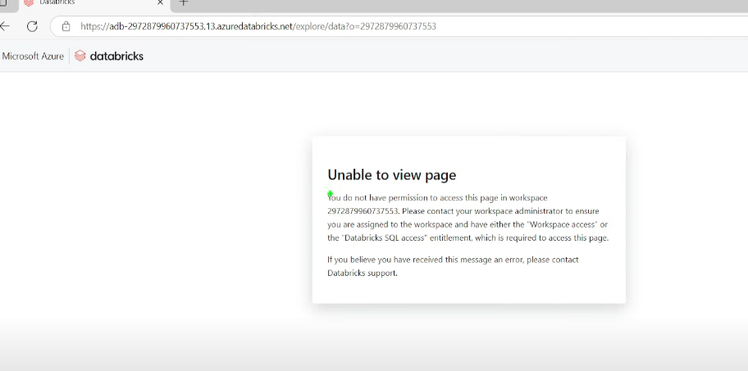  
Adding user in Account Console does not mean she will have access to all the catalogs, account console manages all the workspaces but I want any specific workspace to be given access to.

Step3 : Granting workspace specific access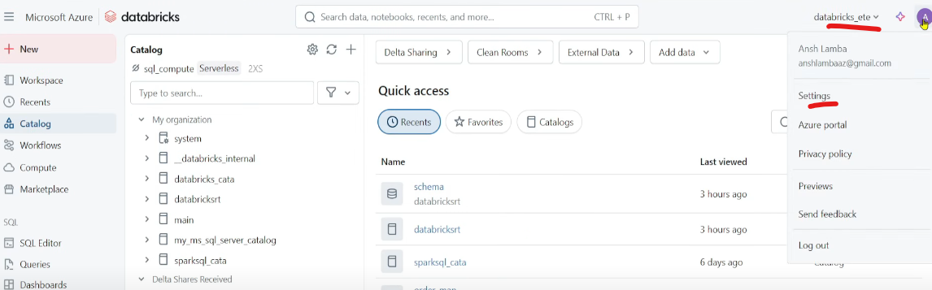 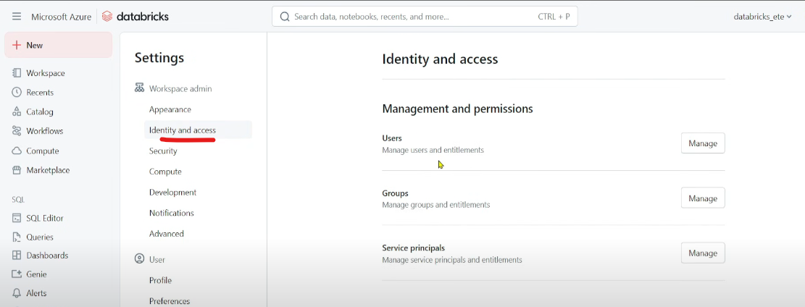  
Best way to create a group 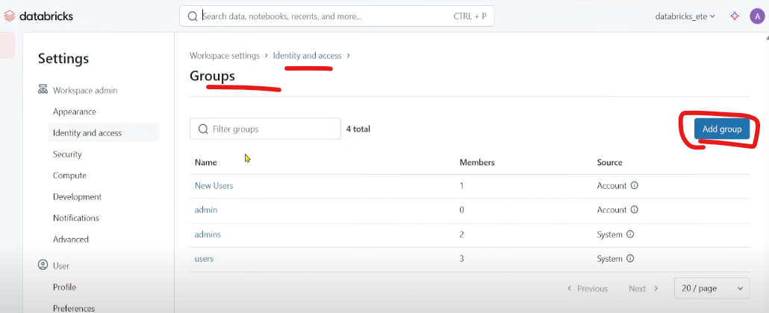 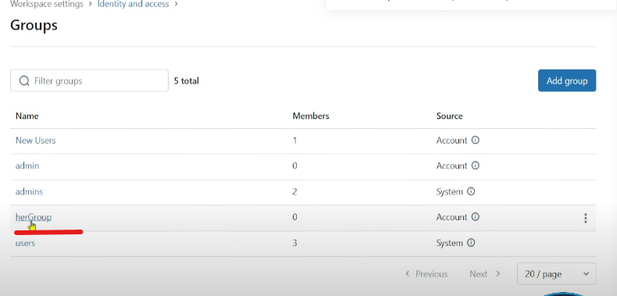  
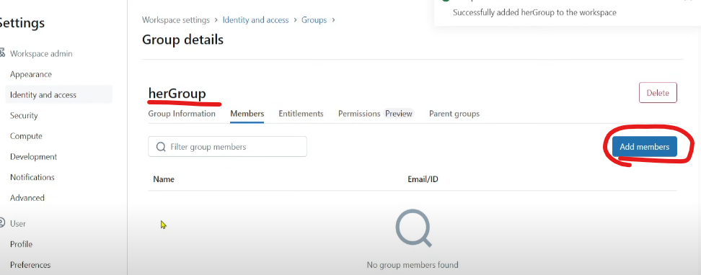 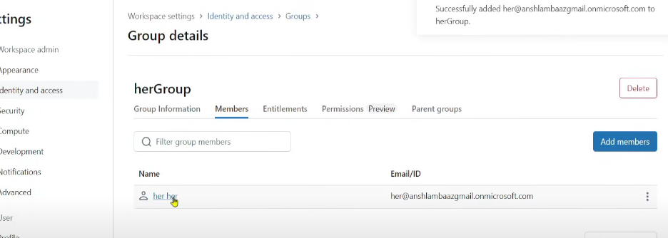 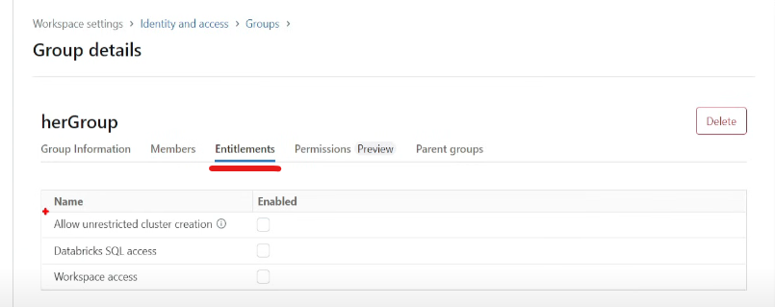 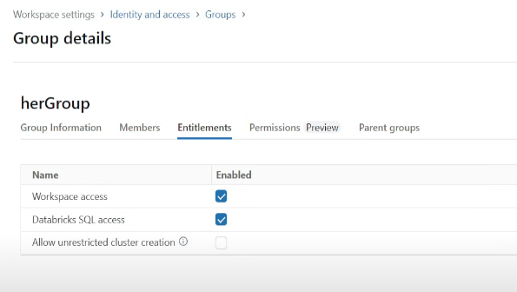  
Still she will not be having access to Catalogs  
  
Step4: Granting access to catalogs 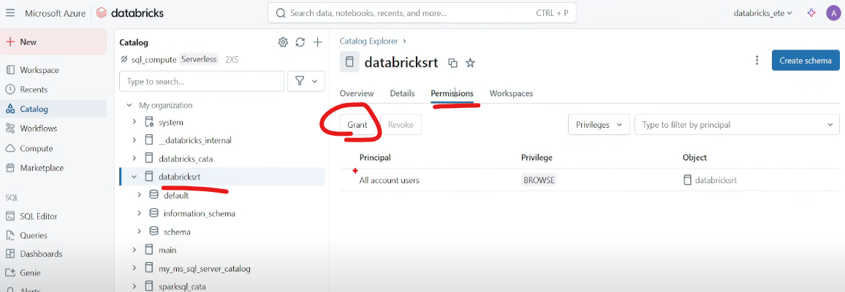  
There are 2 types of access:  
1) Top to Down : having access to parent container will automatically having access to all child containers  
2) Down to Top : having access to a container means all kind of read/write permissions on the container but only usage access to its parent container (if parent container contains any other container, it will be hidden)

Top to Down

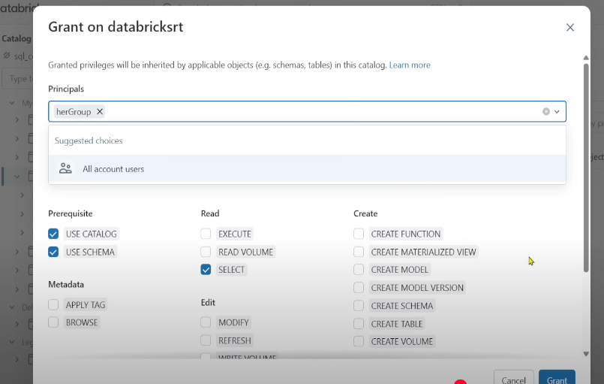

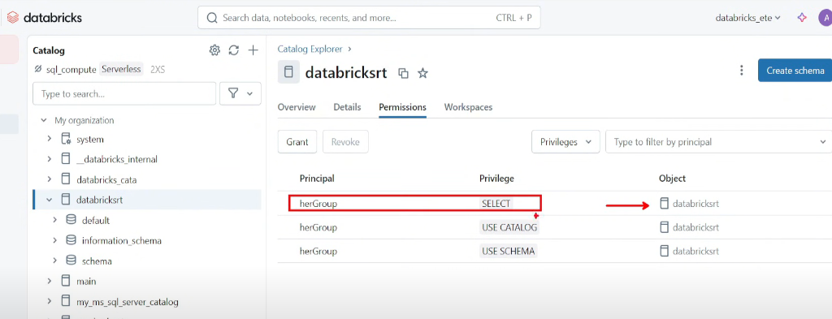  
Add respective access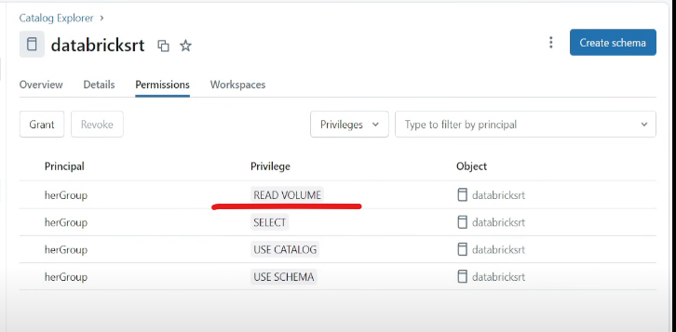

Down to Top  
Lets delete all the access for now 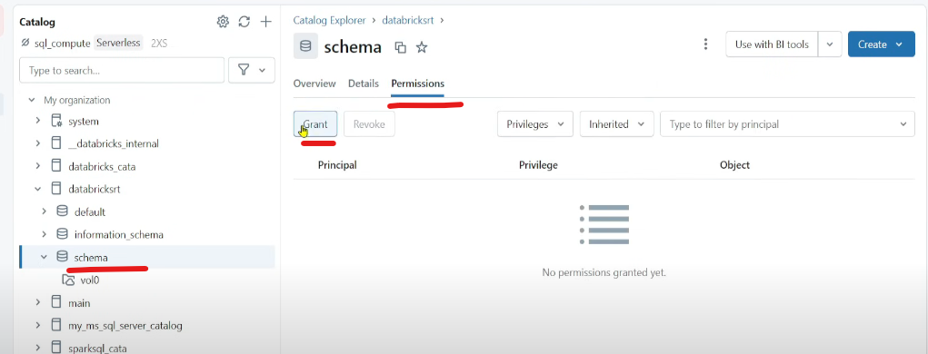  
Go one level down i.e. schema and give permission  
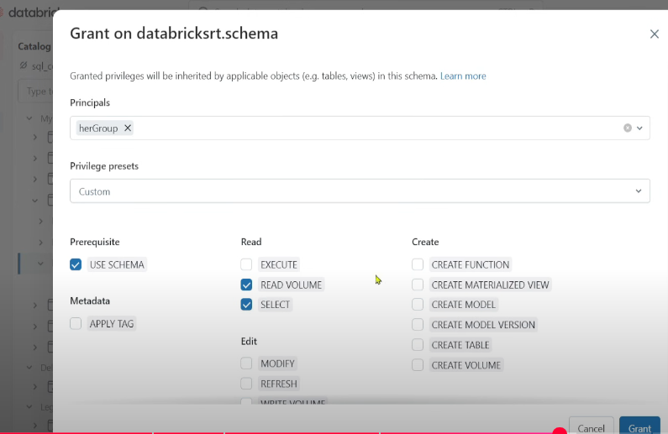 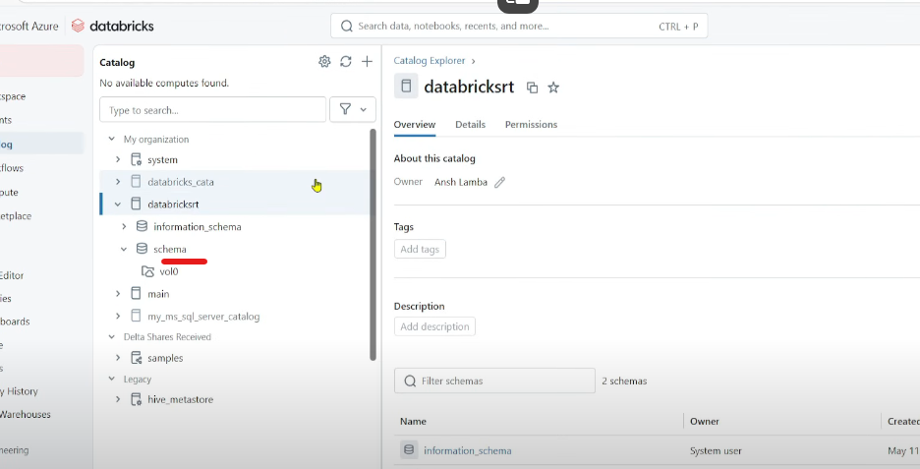  
Note now she cant see the default schema, beauty of down to top approach

**Scenario – 6 (Access on cluster)**  
We don’t want any new user to create new cluster.  
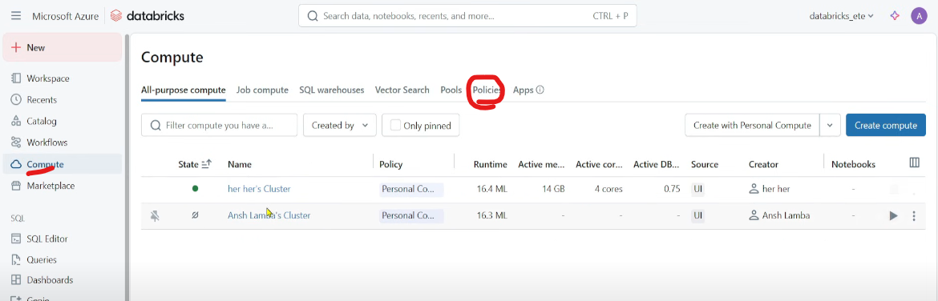 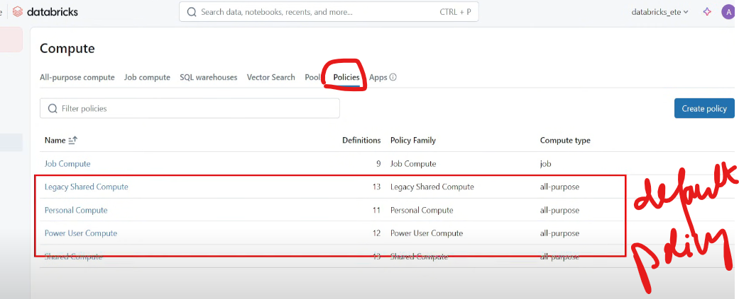Policies are pre defined pre configured area 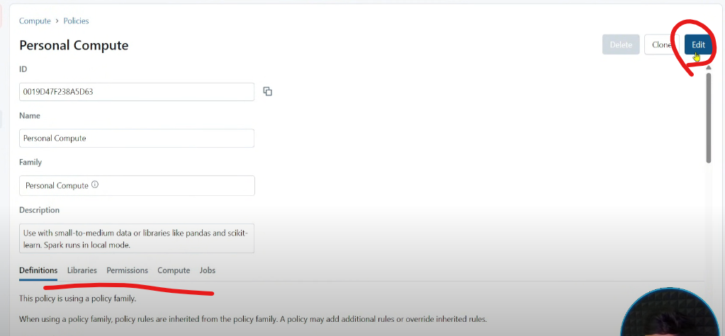

Create a new policy(Copy the code from Personal Compute)  
 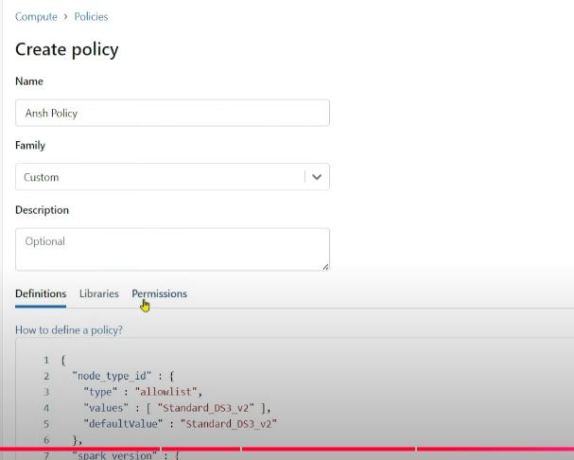  
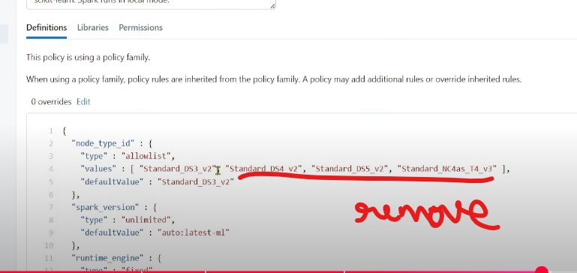  
Means new policy implies only one specific cluster type to be included 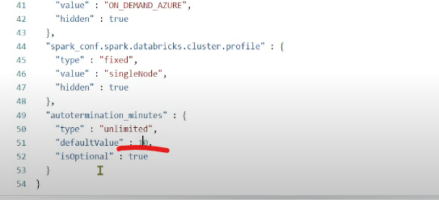Changing 4320 mins to 10 mins 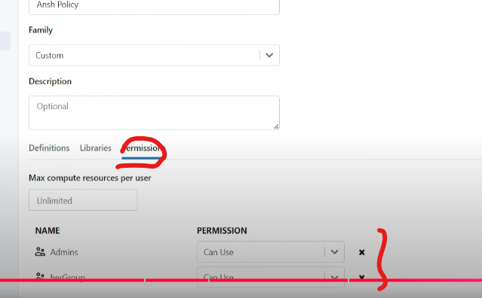  
  
Now try creating a Cluster, all other policies are disabled  
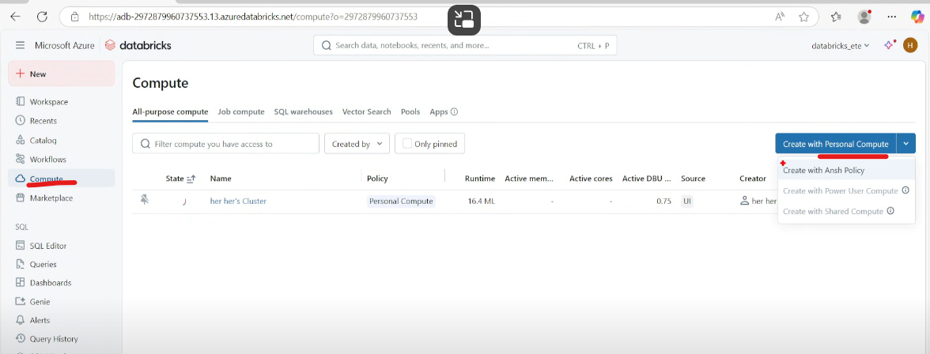 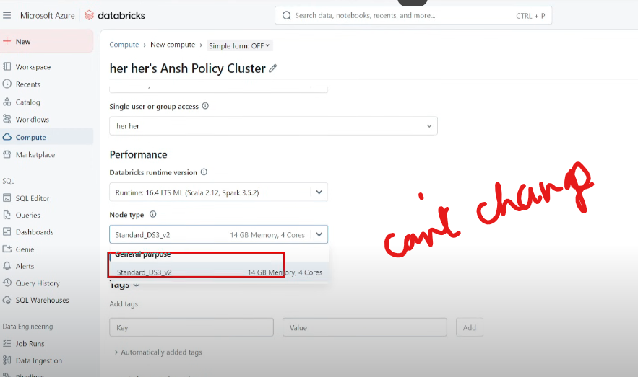 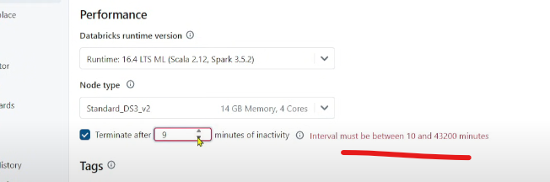

**Scenario-7 (Revoking all users to create Personal Compute)**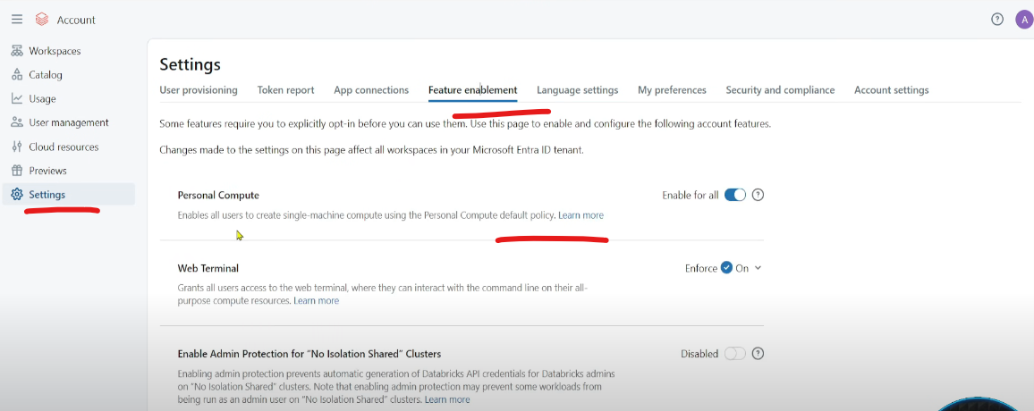 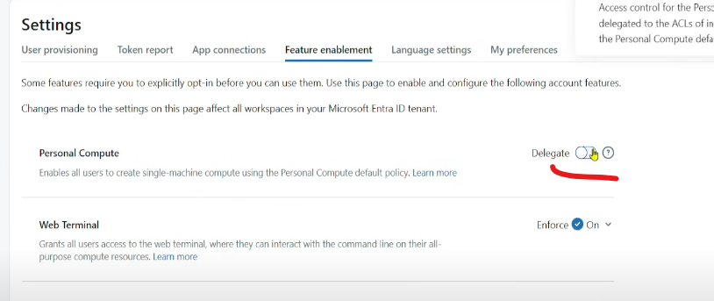 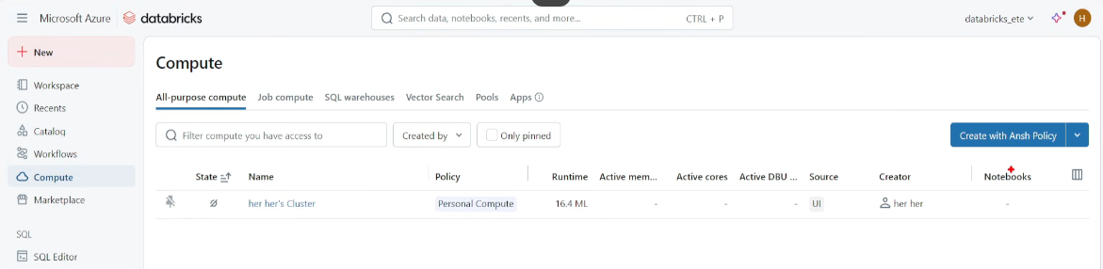  
Personal compute is gone

**Scenario-8 (Databricks Workspace Files)**  
Files in Workspace Files (like json file that we use for Lookup or .py file containing API details)  
Create a new file 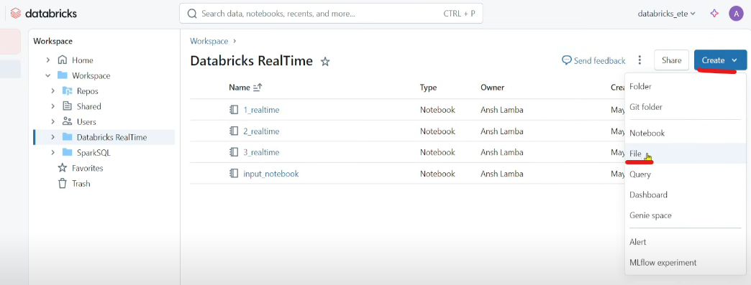  
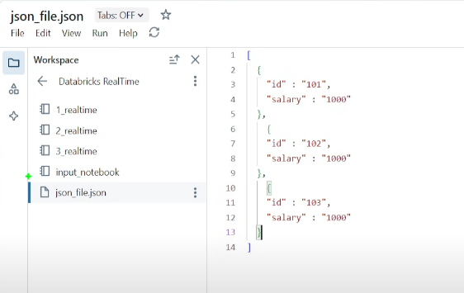  
Create a text file 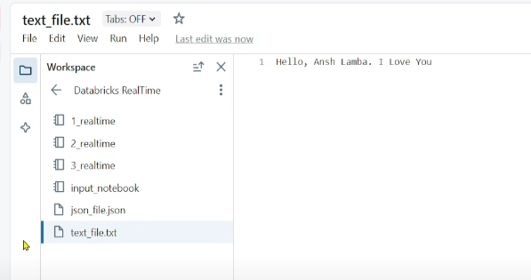  
Create a py file 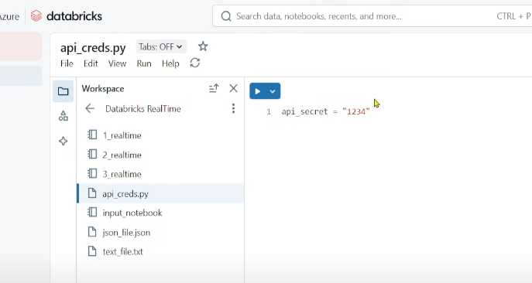  
Create a notebook 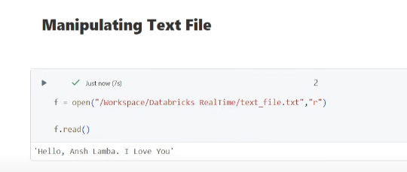  
r means read mode

Writing new line in the file

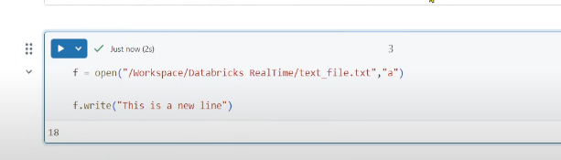 a means append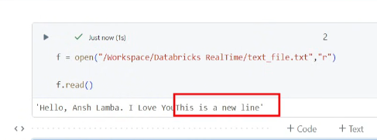

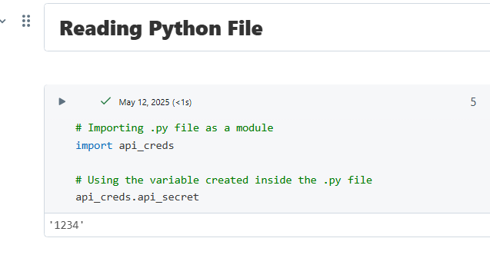

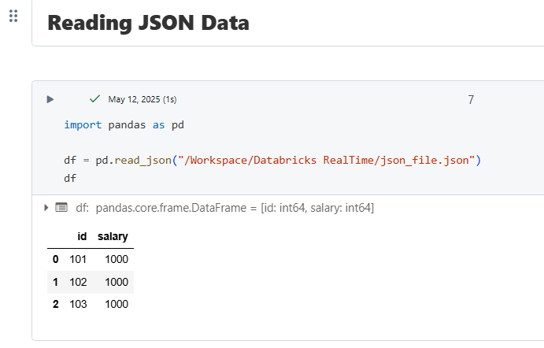

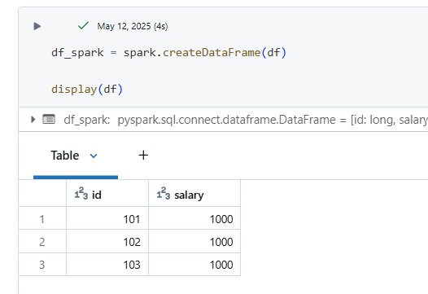To convert into a dataframe 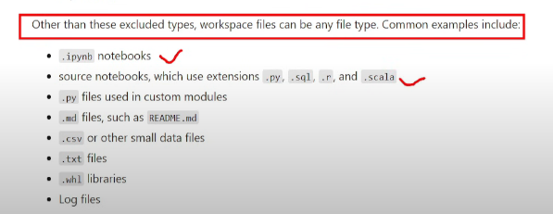

**Scenario-9 (Databricks Delta Sharing)**  
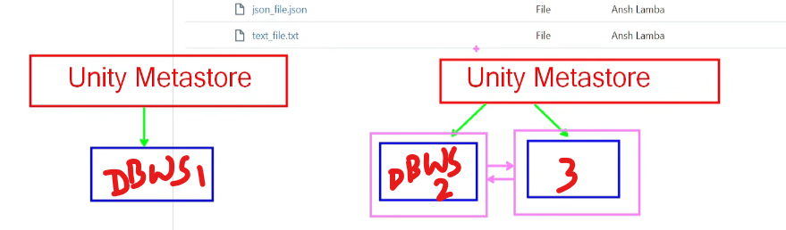  
UM1 attached to WS1 while UM2 attached to WS2 and WS3, now catalogs in WS2 and WS3 can be shared among them as they are connected to same UM, now can I share catalogs of DBWS1 with DBWS 2 or 3? 🡪 Traditionally not possible.

But possible with Delta Sharing   
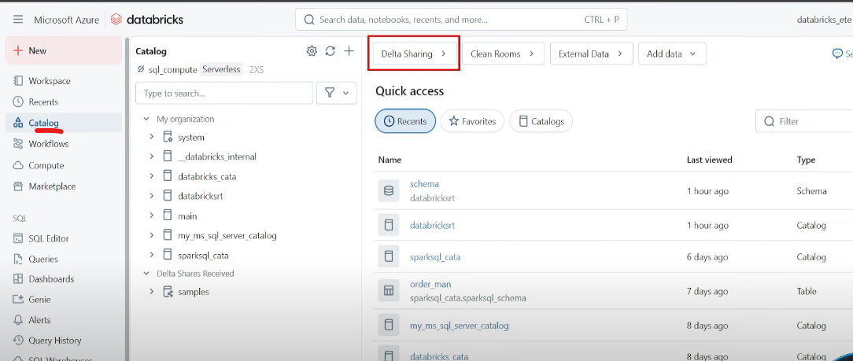  
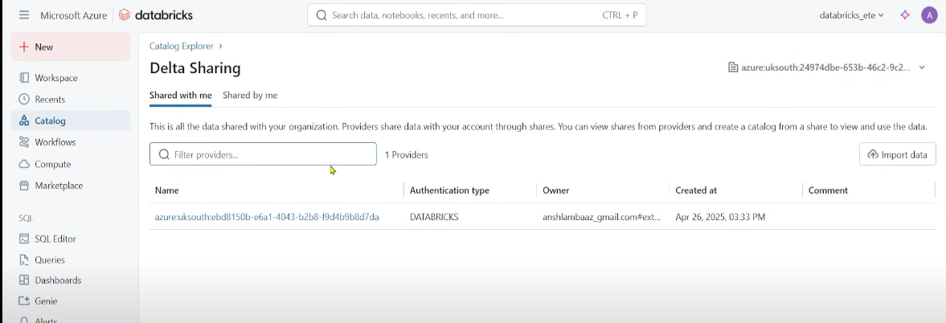  
Catalogs 🡪 Delta Sharing 🡪 create New recipient 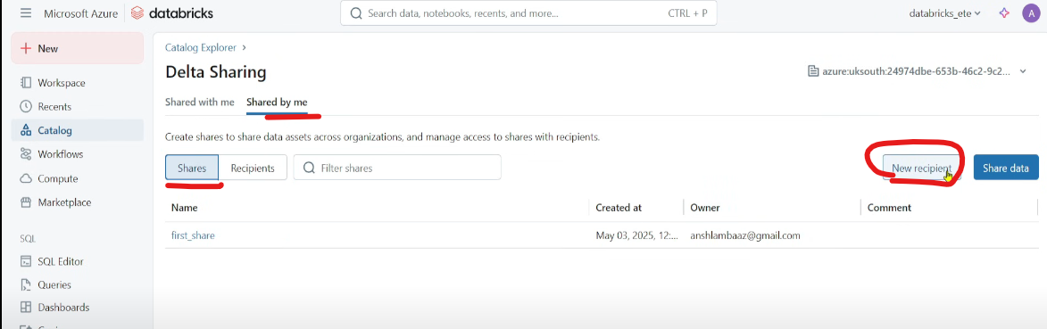 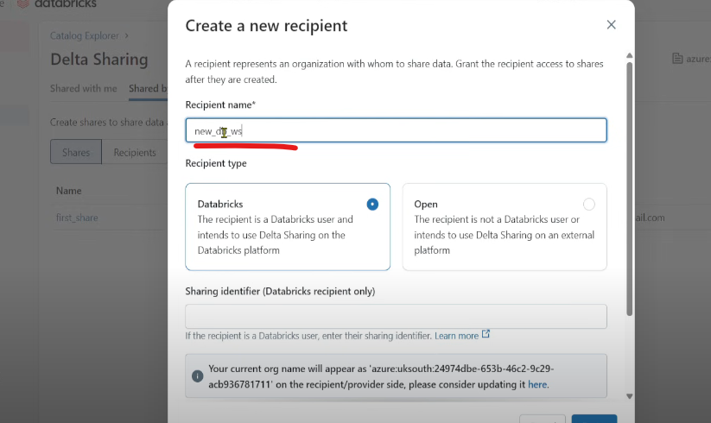  
Sharing identifier: go to other DB, copy highlighted and paste.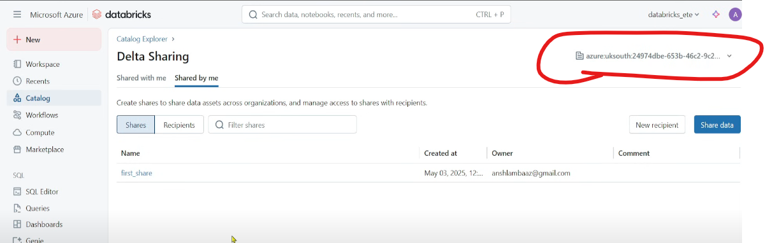  
But that user cant use the catalog 🡪 have to grant permissions 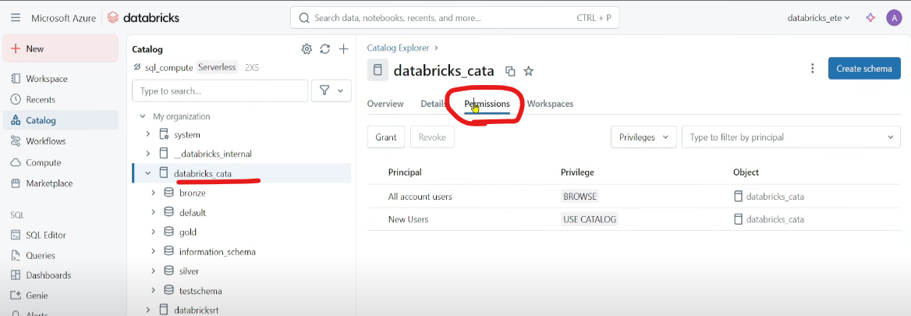 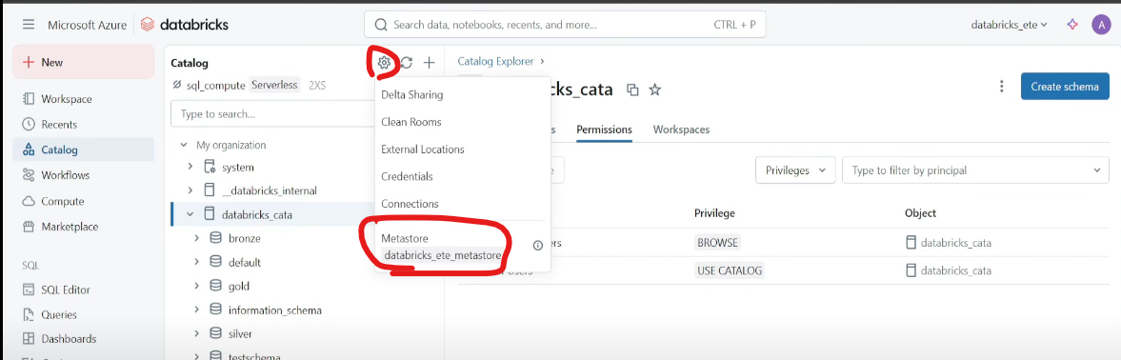  
Click on the metastore(the catalog is attached to this metastore) 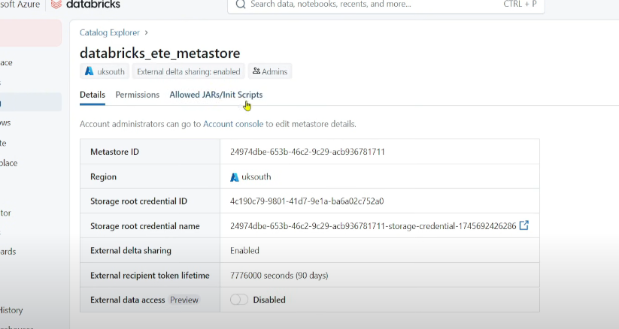 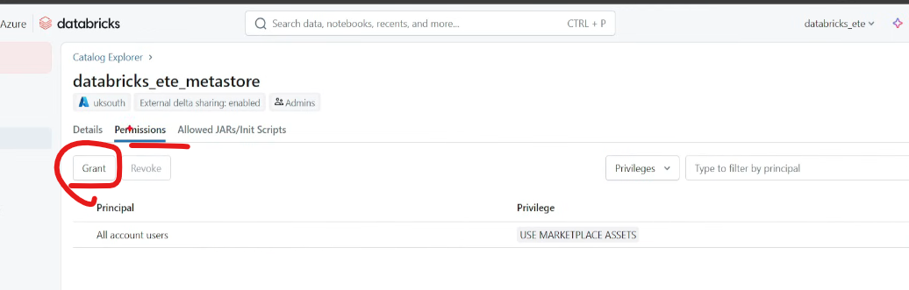 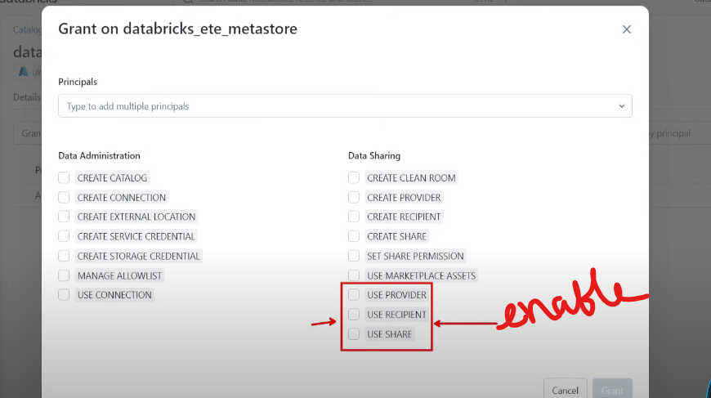

**Scenario-10 (Functions)**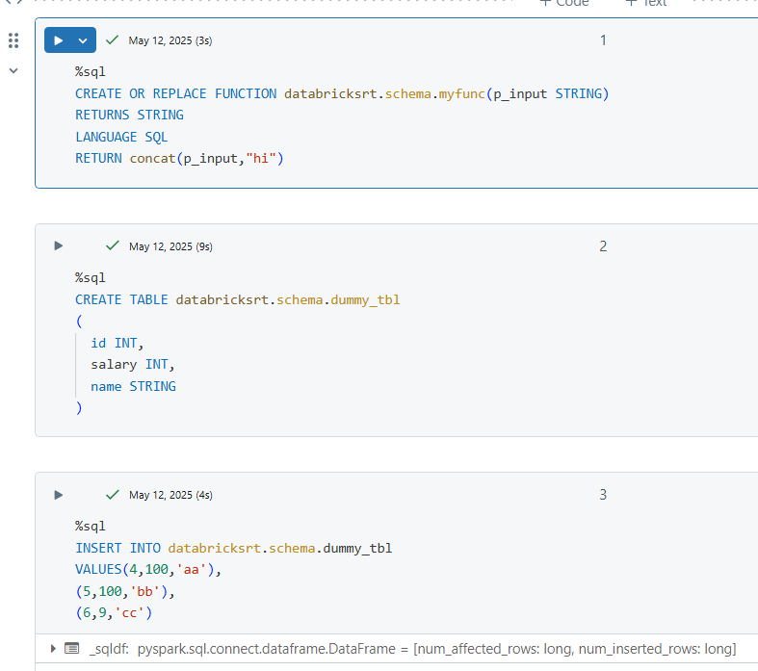 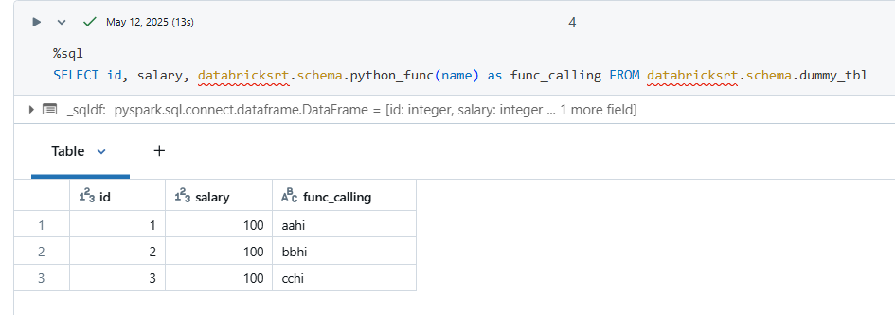 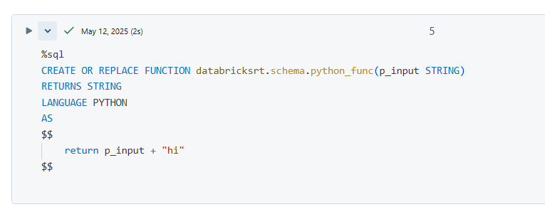

**Scenario-11 (Monitoring & Alerts)**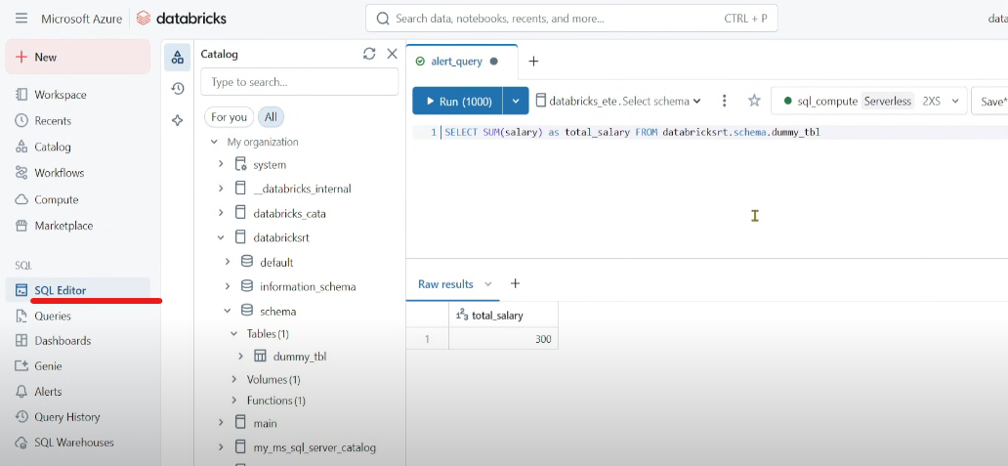   
Save the query as alert_query_new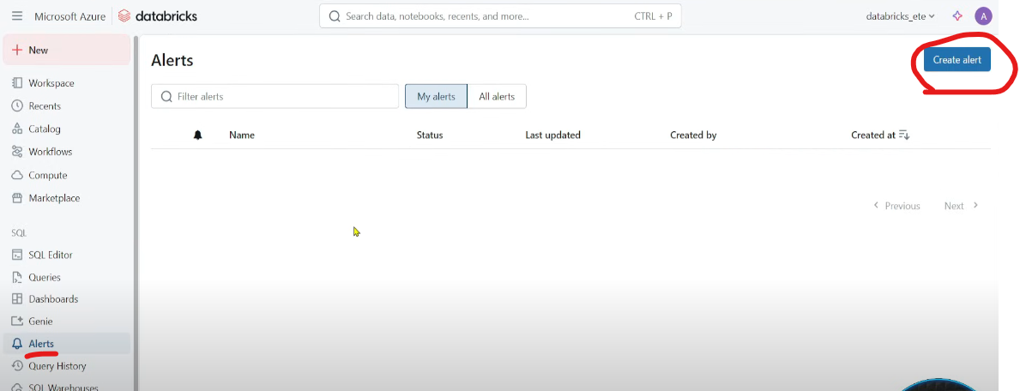 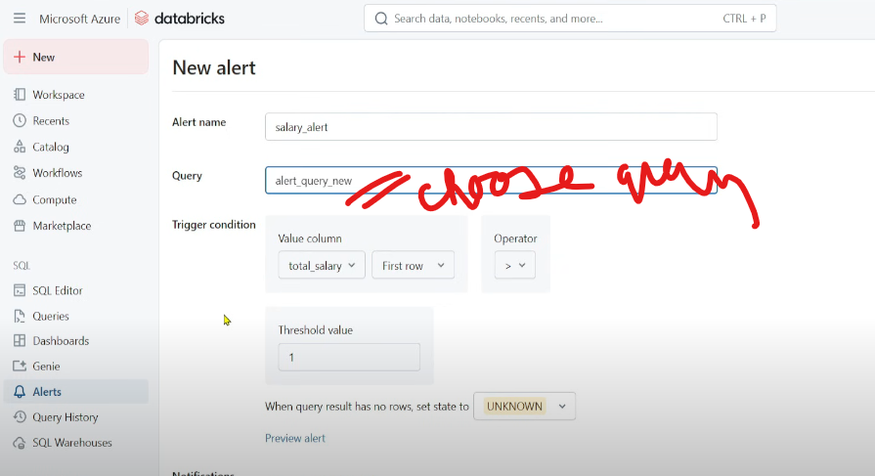  
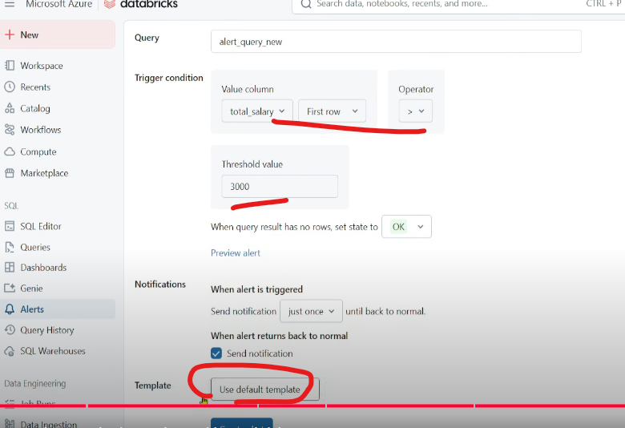 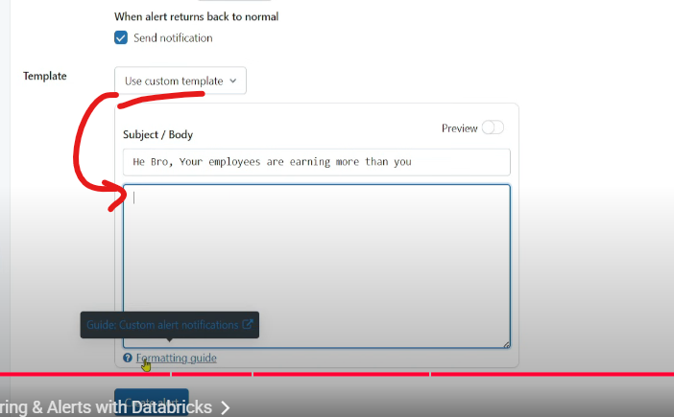 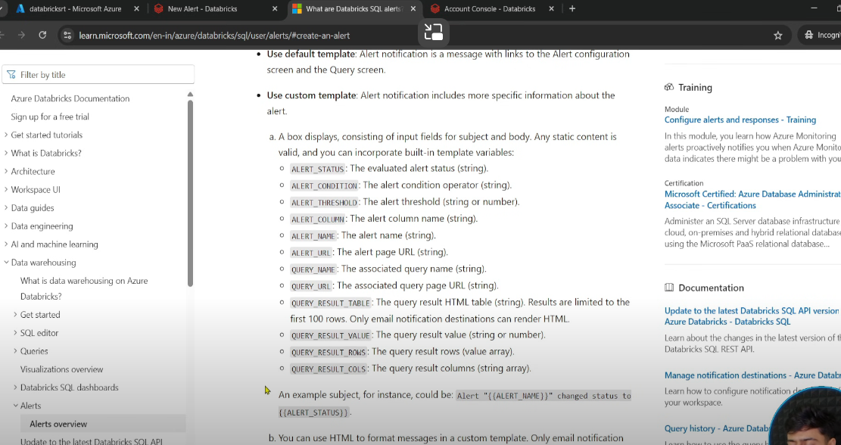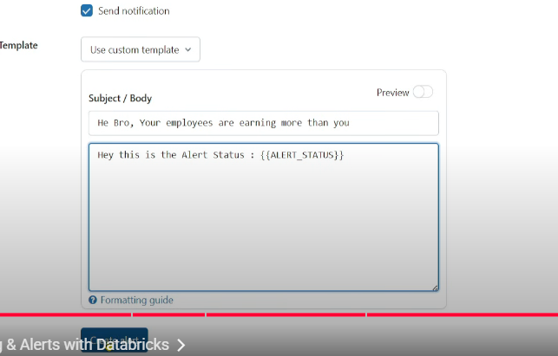 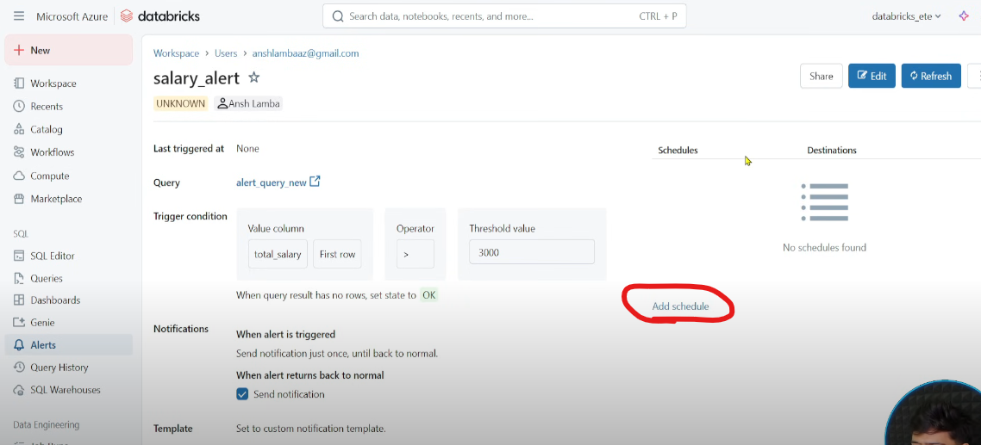  
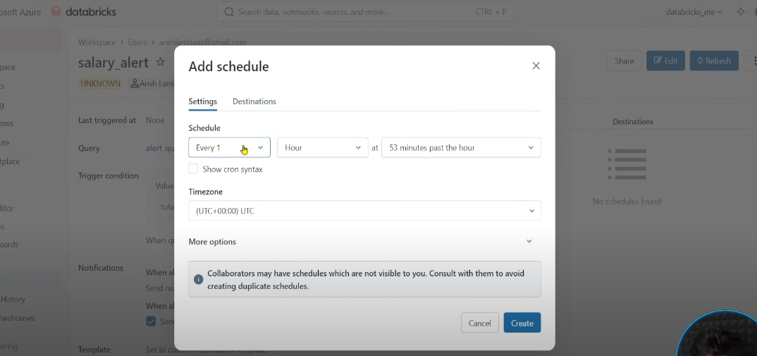  
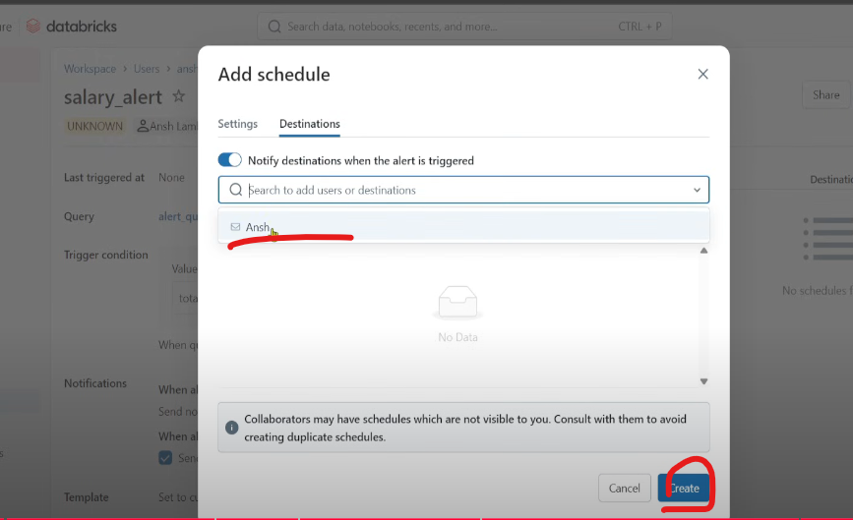  
If destination is not there by default, create one  
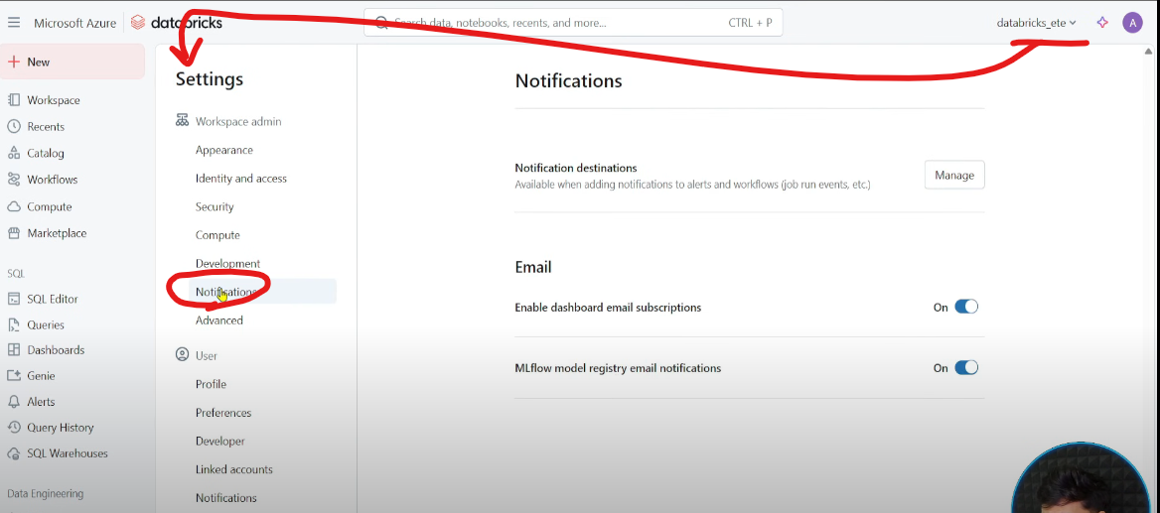  
Manage 🡪 Add destination (email id)